Automotive Sensor for Object Recognition using Red Pitaya and Raspberry Pi

Code directory path in raspberry: home/pi/autonomous-intelligent

Following are the steps to operate this project.

1. Connect red pitaya to power.
2. Connect raspberry to power wait for one minute while it connects to red pitaya
3. Connect screen to raspberry (optional as we integrated sound as well)
4. Connect headset to raspberry
5. Place red pitaya in front of object at the distance of 1 meter
6. Raspberry will play object name
7. If screen is attached it will print name of the object

This software is highly stable, no matter which device is started first even, if any point of time any device disconnected it will establish connection again and run smoothly.

How to add more data for training and run software?

In order to train more data in future go to the file name “data_get_common_code.py”

1. First connect Wi-Fi to red pitaya.
2. Run this file it will connect to red pitaya and capture data repeatedly after 3 sec.
3. Note: change the file name where you want to add new data for object



1. Once data is saves, now we can run the file name “make-feature.py”

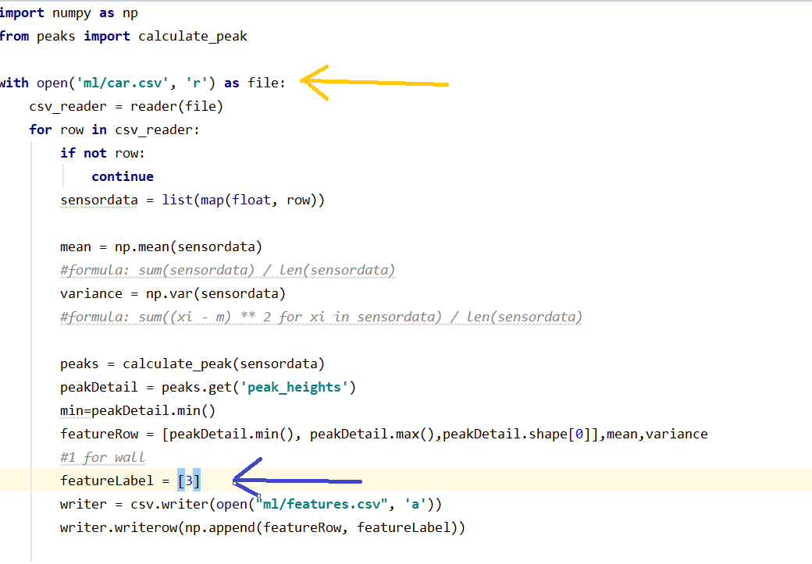

Here need to notice two places

Yellow mark is for file name from where you need to read data which we save in step 3.

blue mark is for label name (1 is for wall,2 for human, 3 for car)

1. Now restart raspberry as detailed above or you can run manually by running file name “object-detection.py”.